P O L A N D
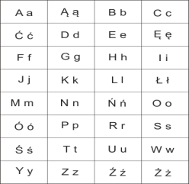
Check your knowledge about Poland!

- Where is Poland located?
- in Central Europe
- in Western Europe
- in Eastern Europe

- When do we celebrate the celebration of independence?
- December 1
- May 3
- November 11

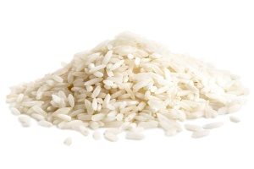
- Which of these things are eaten most often in Poland?
A)

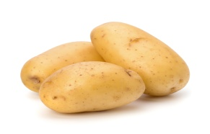
B)

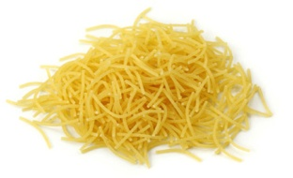
C)

- What is our national sport?
- Soccer
- Basketball
- Handball

- Who was Frederic Chopin?
- pianist, composer
- poet
- writer

- Who was Henryk Sienkiewicz?
- pianist, composer
- poet
- writer

- What does the Polish alphabet look like?
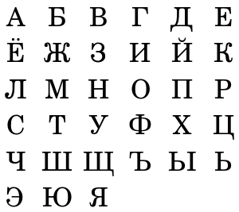
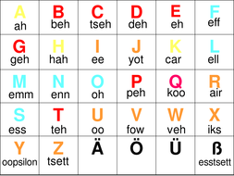
- B) C)

8. What customs is celebrated in Poland?
A) Wet Monday. The second day of Easter. In the tradition of this day, other people pour water on other people for jokes. Water pouring refers to the awakening of nature to life and every year the renewable ability of the earth to give birth.
B) Egg hunt. Egg hunt is a popular game, which means that children look for chocolate eggs in the garden, hidden earlier among grasses, shrubs and even trees by their parents. The search for eggs takes place on the morning of Easter Sunday.
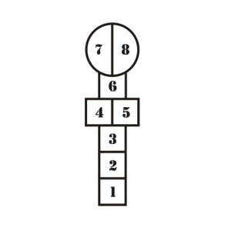
C) Rolling eggs. Iit's rolling eggs from above, wins ten, has an egg will break the last one.
9. What's the name of this popular game?
A) hopscotch
b) hide and seek
C) rounders game
10. What’s the name of the polish capital?
A) Berlin
B) Cracow
C) Warsaw

Author: Aleksandra Lendzion

